Post Lab Questions: Week 6

# Check for Understanding

## Toy Dataset

**1. Describe the large-scale differences between the mapped reads from species 1 and species 2, and explain what this mapping tells us about the relative genome structure of the two genomes that we mapped. If we compared this genomic region in a dot plot, what would it look like? Describe at least one biological mechanism by which this may have occurred.**

A large section of the reference genome is missing (possibly deleted) for species 2, though it is present in species 1. This region spans from ~10.5kb to ~40kb on the reference genome.

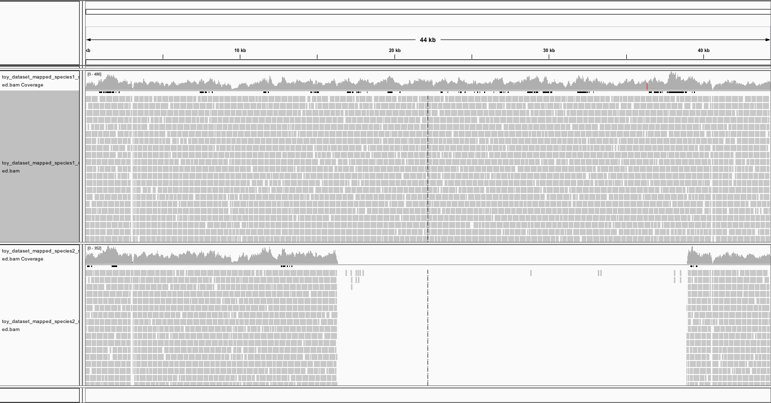

Biological mechanism: HGT

Dot plot:

**2. Do you see evidence of misassemblies? If so, describe where you see evidence for this and what this evidence looks like.**

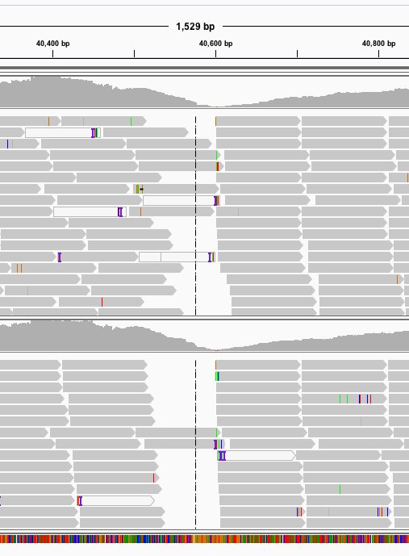

There are some “edges” where reads don’t overlap. Could be evidence of misassembly in the reference. Could also indicate that species 1 and 2 contain a gene that the reference lacks.

**3. Do you see any evidence of single nucleotide polymorphisms? If so, describe where you see evidence for this and what this evidence looks like.**

Not much.

## Project Dataset

**4. If you wanted to quantify the relative abundances of specific genes in your sample, why couldn't you simply count the number of times your gene appears in your assembly?**

Egerg

**5. Do you see evidence of single nucleotide variants? Biologically speaking, what does this indicate? (Keep in mind this is a metagenome from a population of individual organisms vs an assembly, not an individual vs. an individual.)**

aegrg